
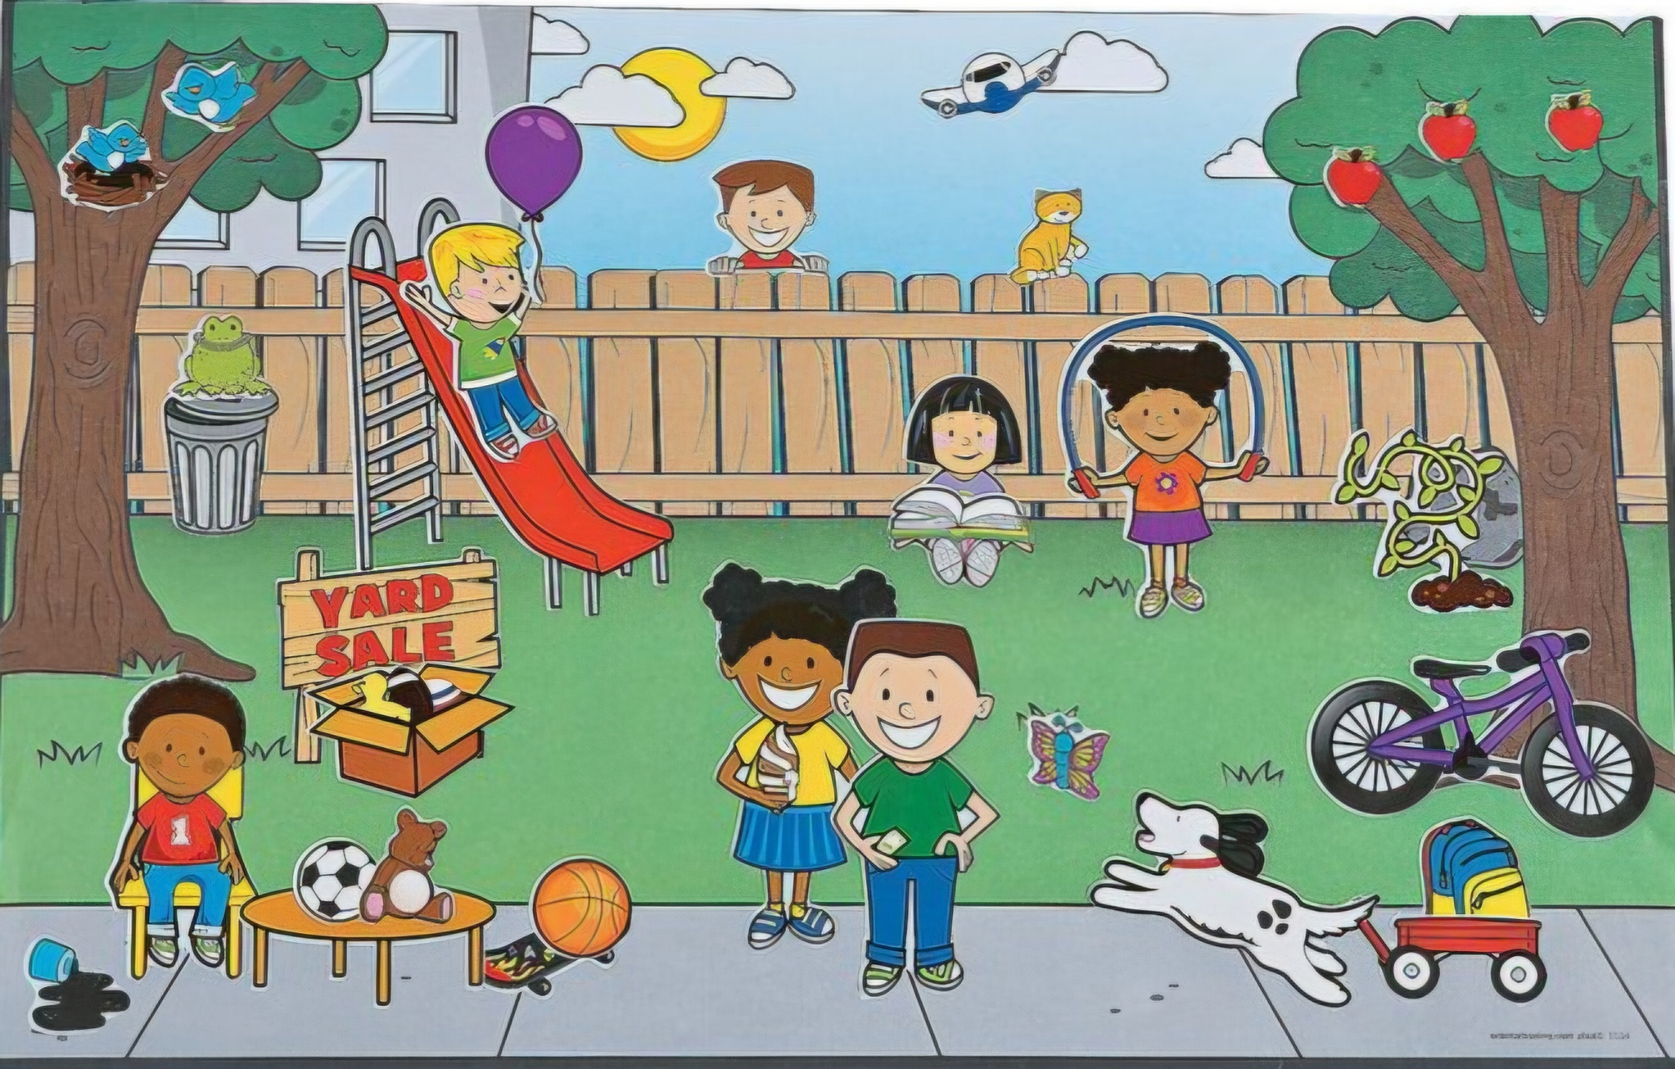
- Observe the picture and justify the sentences with correct prepositions -
- The dog is running _______ the road.
- The toy is ______ the table.
- The apples are hanging ______ the tree.
- An aeroplane is flying ______ the sky.
- A boy is holding balloon ______ his hand.
- The bicycle is kept _______ the tree.
- A girl is sitting and reading _______ the garden.
- The birds have made their nest ______ the tree.
- A box is kept _______ the board.
- The cat is sitting ______ the fence.

